H.T No
Regulations:
A18

Sreenidhi Institute of Science and Technology
(An Autonomous Institution)
Code No: 7C719 Date: 23-Jan-2023 (AN)

B.Tech III-Year II- Semester External Examination, January-2023 (Supplementary)
CMOS DIGITAL IC DESIGN (ECE)

Time: 3 Hours Max.Marks:70

Note: a) No additional answer sheets will be provided.
b) All sub-parts of a question must be answered at one place only, otherwise it will not be valued.
c) Missing data can be assumed suitably.
Bloom's Cognitive Levels of Learning (BCLL)

Remember | L1 | Apply | L3 | Evaluate | L5
Understand | L2 | Analyze | L4 | Create | L6

Part - A Max.Marks:20

Answer all QUESTIONS.

 |  | BCLL | CO(s) | Marks
1 | What is the inverter threshold voltage? | L1 | CO1 | [2M]
2 | Design a CMOS logic circuit for F = (AB+(C+D)) complex logic function. | L3 | CO2 | [2M]
3 | Compare clocked SR latch with SR latch. | L4 | CO3 | [2M]
4 | Find out the output voltage at X and Y for the given circuit  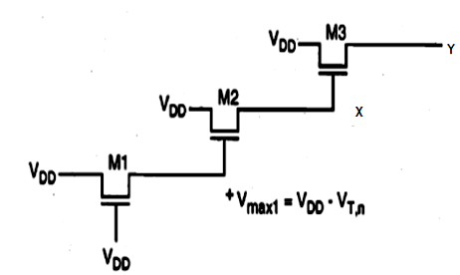 | L1 | CO4 | [2M]
5 | What is the necessity of using a refresh circuit in a Dynamic RAM cell? | L2 | CO5 | [2M]
6 | Compare recurring and non-recurring Engineering cost? | L4 | CO6 | [2M]
7 | Show the generalized NAND structure and its inverter equivalent. | L1 | CO1 | [2M]
8 | Why is D-latch unsuitable for counters and some data storage implementations? | L4 | CO3 | [2M]
9 | Compare Static and Dynamic RAM in terms of performance metrics? | L5 | CO5 | [2M]
10 | What is 2D, 2.5D or 3D capacitance extractor? | L1 | CO6 | [2M]

Part – B Max.Marks:50
ANSWER ANY FIVE QUESTIONS. EACH QUESTION CARRIES 10 MARKS.

 |  |  | BCLL | CO(s) | Marks
11. | a) | Determine the VOL and VOH of CMOS logic circuits? | L5 | CO1 | [5M]
 | b) | Evaluate the effect of transistor size on the transient response with example. | L5 | CO1 | [5M]
12. | a) | Design a NAND 2 gate using CMOS logic circuit with layout. | L3 | CO2 | [5M]
 | b) | Compare Pseudo logic and CMOS logic of 2-input NOR with suitable circuits. | L4 | CO2 | [5M]
13. | a) | Design a CMOS negative edge triggered master slave flip flop. | L3 | CO3 | [5M]
 | b) | How can the not-allowed state problem of SR latch circuits be solved by using JK flip flop with suitable circuits? | L2 | CO3 | [5M]
14. | a) | Design a dynamic 4 stage shift register using Synchronous Dynamic Circuit Techniques. | L1 | CO4 | [5M]
 | b) | How can voltage bootstrapping overcome the threshold voltage drop? Explain with examples. | L2 | CO4 | [5M]
15. | a) | Explain about the programming and erase operation of flash memory using CHE injection and F-N tunneling. | L2 | CO5 | [5M]
 | b) | Design a 3T DRAM cell with the pull-up and read/write circuitry. | L3 | CO5 | [5M]
16. | a) | Explain about the Timing-driven placement design flow. | L2 | CO6 | [5M]
 | b) | Explain about the Mixed-signal or custom-design flow. | L2 | CO6 | [5M]
17. | a) | Show the Logic circuit and CMOS circuit of given Boolean function  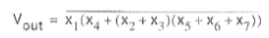 | L1 | CO1 | [4M]
 | b) | Illustrate the generalized NOR structure with multiple inputs. | L3 | CO2 | [3M]
 | c) | Design a clocked NOR based SR flip flop with AOI based implementation. | L3 | CO3 | [3M]
18. | a) | Design a domino logic circuit of Z = AB + (C + D)(C + D) + GH complex logic function. | L3 | CO4 | [4M]
 | b) | Explain about the typical Random Access memory array Organization | L2 | CO5 | [3M]
 | c) | Discuss about the Platform-Based Design in System on a Chip | L2 | CO6 | [3M]

-- 00 -- 00 –

